

Leadership Compass for Generative AI Defense
Jonathan Care
October, 2026

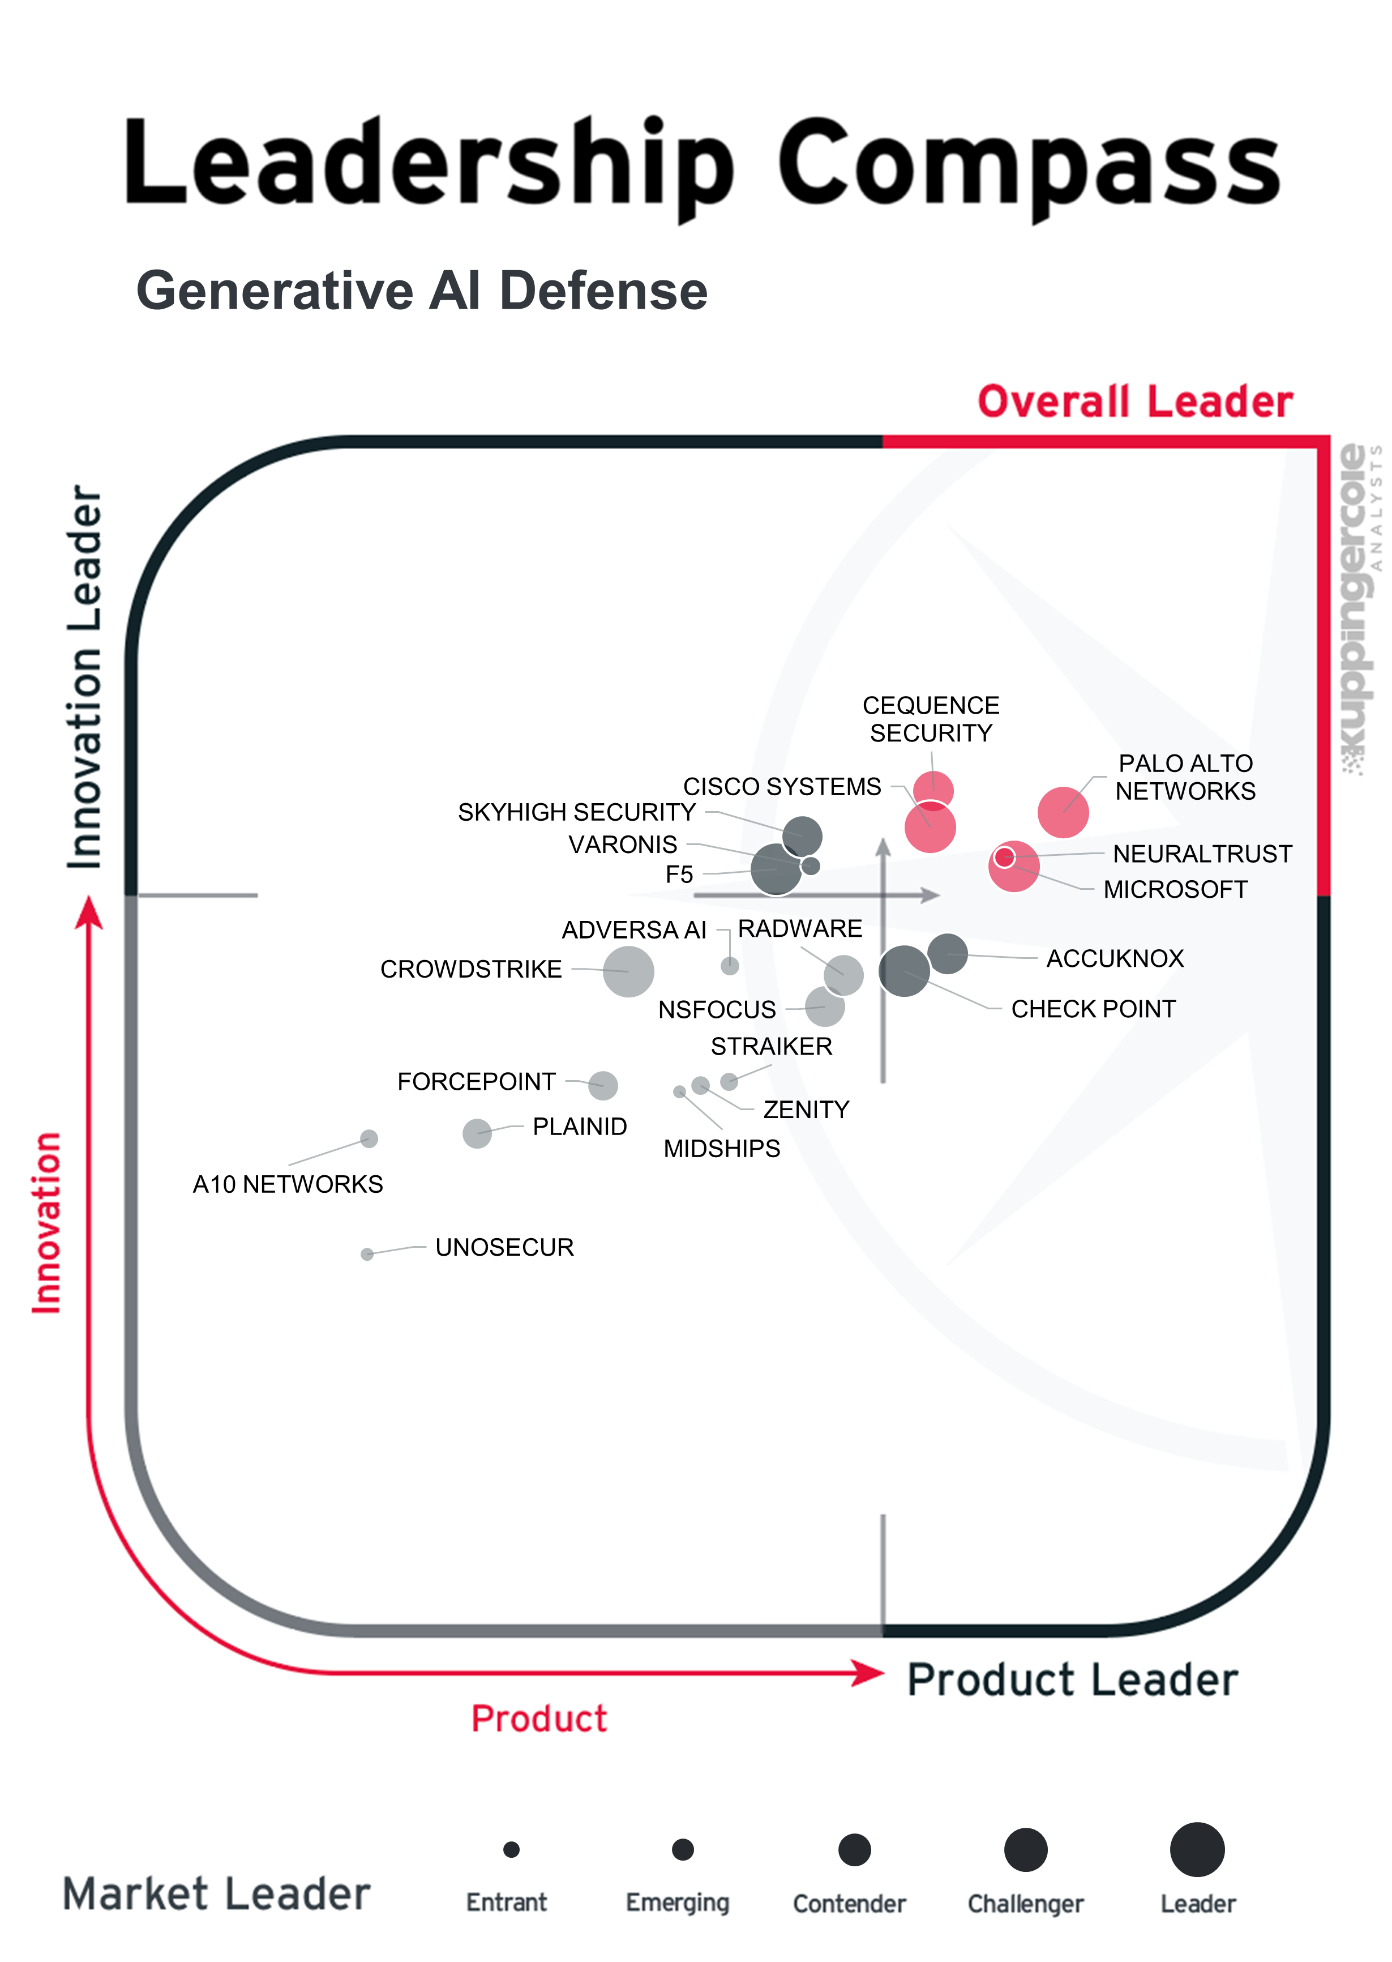

Generative artificial intelligence (AI) is spreading across business workflows faster than security controls can follow, exposing organizations to data leakage and harmful output, and exposing models to prompt injection, jailbreaking, and poisoning. This Leadership Compass helps Chief Information Security Officers (CISOs) and security leaders decide which controls to deploy for internally hosted and foundation provider models, and whether to source them from a security platform or a specialist, in a market reshaped by rapid innovation and acquisitions.
Contents
Introduction 4
Key Findings 4
Market Analysis 5
Delivery Models 6
Required Capabilities 7
Leadership 9
Overall Leadership 9
Product Leadership 11
Innovation Leadership 11
Market Leadership 12
Product and Vendor Evaluation 14
A10 Networks – TrojAI 17
AccuKnox – AI Security 21
Adversa AI – Agentic Security Platform 27
Cequence Security – AI Gateway 32
Check Point – AI Defense Plane 37
Cisco Systems – AI Defense 43
CrowdStrike – Falcon Guardian 49
F5 – AI Security Platform 55
Forcepoint – AI Data Security Platform 61
Microsoft – Security for AI 66
Midships – Icebreaker 72
NeuralTrust – AI Security Platform 77
NSFOCUS – NSFAIS 83
Palo Alto Networks – Prisma AIRS 88
PlainID – Runtime Authorization Platform 93
Radware – Agentic AI Protection 98
Skyhigh Security – Skyhigh AI Security 103
Straiker – AI Security Platform 109
Unosecur – MCP and AI Governance Gateway 114
Varonis – Atlas AI Security 119
Zenity – AI Agent Security and Governance Platform 124
Related Research 129
Copyright 129

Introduction
Generative AI is no longer an experiment; it is embedded in customer service, software development, knowledge management, and a growing number of business workflows. Many organizations have adopted Large Language Models (LLMs) faster than they have adapted their security controls, relying on guardrails supplied by foundation model providers or on existing tools that were not designed for natural language attacks. The result is exposure in two directions. Organizations need protection from the LLM, against data leakage, harmful or inaccurate output, and uncontrolled agent actions; the LLM needs protection from the organization and its users, against prompt injection, jailbreaking, model and data poisoning, and misuse of connected tools.
Internally hosted models give security teams control over the model, its training data, and its runtime environment, while models consumed from a foundation provider limit visibility and shift the focus to what enters and leaves the model: prompts, retrieved content, outputs, and tool calls. Both deployment types must also address emerging AI regulation such as the European Union (EU) AI Act, and existing data protection obligations such as the EU’s General Data Protection Regulation (GDPR). Each deployment type balances protection, latency, and usability differently. For security leaders, the question is which controls to deploy, where to place them, and whether to source them from an existing security platform or a specialist.
From our perspective, the market is moving toward a clear separation between vendors offering generative AI defense as a module within a broader security platform, such as Security Service Edge (SSE) or Data Loss Prevention (DLP), and those delivering specialized, AI-native solutions. The former offers depth and integration; the latter provides speed of innovation and niche expertise. Consolidation suits organizations that consume models from foundation providers through traffic an existing security platform already sees; specialized products suit organizations that host models internally or give agents tool access. In both cases, weigh implementation effort, integration with security operations, and cost, and align generative AI defense with broader AI governance strategy.
In this Leadership Compass, we assess solutions that help organizations do both: protect the organization from the LLM and protect the LLM from the organization, from model development and deployment through runtime operation. To better understand the fundamental principles this report is based on, please refer to KuppingerCole Analysts Research Methodology.

Key Findings
- KuppingerCole rated 21 products, seven of them from specialists founded in 2020 or later.
- The five Overall Leaders are Palo Alto Networks, Cisco Systems, Cequence Security, Microsoft, and NeuralTrust. NeuralTrust, founded in 2022, is a Product and Innovation Leader despite an Emerging market position, which shows that specialists can compete with the largest security vendors on capability.
- Prompt injection prevention is the most mature capability: 17 of 21 products score at least 70% of the maximum in this area. Here and below, scores are the capability ratings shown in each product's spider chart, and the maximum is the highest rating possible for that capability.
- Most vendors now offer AI security posture management (20 of 21 products), and agentic AI security follows closely (18 of 21). Agentic AI security scores still range widely, so buyers deploying AI agents should test vendor claims.
- Protection against attacks on the model is more mature than protection of the data it processes. Data leakage prevention and content safety filtering are widely supported, but support remains limited at the lower end of the field.
- Model security controls are a clear gap. Only 4 of 21 products score at least 70% of the maximum, a shortfall for organizations that host, fine-tune, or train their own models.
- Support for governance frameworks is the least developed area, with only two products offering mature support. Few vendors hold independent certifications such as Common Criteria, even as the EU AI Act raises compliance expectations.
- Interoperability varies more than any other capability. Buyers should confirm integration with their existing security operations, identity, and data security tools before committing.
- Many vendors are small or early-stage: financial strength is rated weak or critical for 7 of 21 vendors, and market position is weak for 6. With consolidation continuing, buyers should include vendor viability in their selection criteria.

Market Analysis
Investment in generative AI is concentrated in the models themselves and the infrastructure that runs them. The Stanford AI Index 2026 reports that generative AI accounted for more than half of US private AI investment in 2025, at $163.6 billion, and Menlo Ventures estimates that enterprise generative AI spending rose from $11.5 billion in 2024 to $37 billion in 2025. In our view, spending on securing these models and their use has not kept pace. Most organizations still rely on the safety controls built into foundation models, or on existing security tools that inspect network traffic and files but cannot interpret prompts, model output, or agent actions.
The Generative AI Defense market has formed in response to this gap. It covers controls that protect the organization from the LLM, such as preventing sensitive data from reaching external models, filtering harmful or inaccurate output, and constraining what AI agents can do. It also covers controls that protect the LLM from the organization and its users, such as detecting prompt injection and jailbreak attempts, preventing model and data poisoning, and securing the tools and data sources that models connect to. Both apply to models that generate code, images, and audio as well as text.
Vendors in this market fall broadly into two groups. On one side are established security platforms, including SSE, DLP, API security, and cloud security vendors, which have added generative AI controls to products their customers already run. On the other side are AI-native specialists that focus on model and prompt security, and often lead on detection accuracy and coverage of new attack techniques. Acquisitions such as Cisco and Robust Intelligence, Palo Alto Networks and Protect AI, Check Point and Lakera, and F5 and CalypsoAI are moving specialist technology into the platforms at a fast pace, so buyers should weigh product roadmap, vendor stability, and current capabilities.
The market is not yet mature. Attack techniques against generative AI models change quickly, and detection often depends on probabilistic classifiers that produce false positives and add latency. Standards are still forming: the Open Worldwide Application Security Project (OWASP) Top 10 for LLM Applications, MITRE Adversarial Threat Landscape for Artificial-Intelligence Systems (ATLAS), and the National Institute of Standards and Technology (NIST) AI Risk Management Framework (RMF) give useful structure, but they do not yet define consistent test methods for comparing products. Agentic AI adds further risk, because agents act with delegated permissions, call external tools, and can chain actions without human review.
Regulation is increasing pressure on buyers. The EU AI Act introduces obligations for providers and deployers of AI systems, including risk management, logging, and human oversight, while data protection laws such as GDPR continue to apply to personal data in prompts and outputs. Many organizations also set responsible AI policies that go beyond legal requirements, such as limits on biased or unfair output, and expect security controls to enforce them. Selecting a solution therefore means not only blocking attacks, but also producing the evidence that governance, risk, and compliance teams need, and fitting controls to where each organization’s models run and how they are used.

Delivery Models
Controls sit at several points in the AI stack. AI gateways and firewalls inspect prompts and responses in transit between users, applications, and models. Runtime guardrails run with the model to enforce content and behavior policies. Data security controls classify and redact sensitive information before it enters prompts, retrieval pipelines, or training data. Model and supply chain scanning tests models, datasets, and third-party components for vulnerabilities and malicious content before deployment. Agent and tool governance controls which Application Programming Interfaces (APIs), data sources, and actions an AI agent can use, and under whose identity. Discovery and posture management tools identify which AI services are in use across the organization, including unsanctioned ones. Detection and response capabilities monitor AI systems for probing and active attacks, alert security operations teams, and trigger automated containment.
Generative AI Defense solutions are delivered in several ways, and most vendors support more than one. Proxy and gateway deployments place controls inline between users or applications and the model, either as a cloud service or as part of an existing SSE or network security platform. This approach requires little change to applications and works for both foundation provider and internally hosted models, but it adds a network hop and only sees traffic that passes through it.
API and Software Development Kit (SDK) integrations embed controls directly in applications, retrieval pipelines, and agent frameworks. They give more context and finer control, at the cost of development effort. Browser extensions and endpoint agents address employee use of public AI services. For internally hosted models, vendors also offer container-based deployments that run in the customer’s own cloud or data center, which suits cases where data residency, sovereignty, or latency requirements rule out sending prompts to a third-party service.
Licensing models vary widely. Common approaches include per-user pricing for employee AI usage controls, per-request or per-token pricing for runtime protection, and per-model or per-application pricing for scanning and testing. Buyers should understand how costs scale as AI usage grows, especially where agents generate large volumes of model calls without direct user interaction. Solutions should also scale from a single department or application to enterprise-wide use across many models, with central policy management and consistent reporting.

Required Capabilities
The criteria below follow the 2025 market segment definition and extend it to cover AI agents, retrieval pipelines, and AI security posture management, reflecting how the market has developed since. The following is a list of criteria for evaluation in this Leadership Compass on Generative AI Defense:
- Discovery of AI services, models, and agents in use, including unsanctioned (shadow) AI
- AI posture management: inventory, configuration assessment, and risk scoring of models and AI applications
- Risk classification of AI applications by potential impact, with controls applied according to risk level
- Detection and blocking of direct and indirect prompt injection
- Jailbreak detection and prevention
- Sensitive data detection and redaction in prompts, responses, and retrieved content
- Output filtering for harmful, biased, toxic, off-topic, or policy-violating content
- Detection of ungrounded or hallucinated output in Retrieval-Augmented Generation (RAG) applications
- Protection across text, code, image, and audio inputs and outputs, including attacks hidden in images, audio, and documents
- Protection of training and fine-tuning data, including defense against model and data poisoning
- Protection of models against unauthorized access, tampering, and extraction, including model inversion and training data extraction attacks
- Model and AI supply chain scanning, including serialized model files, datasets, and third-party components
- Automated red teaming and adversarial testing of models and AI applications
- Security of RAG pipelines, including access control on vector databases and retrieved documents
- Agent and tool governance: control over which tools, APIs, and data an AI agent can access
- Security for Model Context Protocol (MCP) servers and agent-to-agent communication
- Identity-aware policies that bind AI usage and agent actions to human or workload identities
- Authentication and authorization controlling who can use each AI application, model, and agent, and with what privileges
- Policy engine to define and enforce usage, content, and data policies per user, application, and model
- Support for major foundation model providers and self-hosted open-weight models
- Flexible deployment (Software as a Service (SaaS), gateway/proxy, API/SDK, and customer-hosted)
- Low-latency inline enforcement suitable for production applications
- Real-time detection of probing and active attacks against AI systems, with alerting
- Incident response playbooks and automated remediation for AI security events
- Logging and audit trails of prompts, responses, and policy decisions, with privacy controls
- Integrations with Security Information and Event Management (SIEM), Security Orchestration, Automation and Response (SOAR), and Information Technology (IT) Service Management (ITSM) systems
- Mapping of controls to the OWASP Top 10 for LLM Applications, MITRE ATLAS, and the NIST AI Risk Management Framework
- Reporting to support EU AI Act and other regulatory compliance
- Data localization/residency options for prompts, logs, and telemetry
The following items are considered as additional and innovative capabilities:
- Behavioral analysis of AI agents to detect anomalous or unauthorized action sequences
- Human-in-the-loop approval workflows for high-risk agent actions
- Continuous red teaming that adapts as new attack techniques emerge
- Watermarking or provenance tracking for AI-generated content
- Use of generative AI for natural language policy authoring, investigation, and reporting
- Cost and usage controls, such as token budgets and rate limits per user, application, or agent

Leadership
Selecting a vendor of a product or service must not be based only on the information provided in this KuppingerCole Analysts Leadership Compass. The Leadership Compass provides a comparison based on standardized criteria and can help identify vendors that should be considered for further evaluation. However, a thorough selection process should include a detailed analysis and a Proof of Concept (PoC) or pilot phase, based on the specific criteria of the customer.

Overall Leadership
The Overall Leadership chart reflects how vendors balance product strength, innovation, and market presence. The chart evaluates vendors in this market across two dimensions. The horizontal axis measures Product Leadership, and the vertical axis measures Innovation Leadership. Overall Leaders are those in the upper right-hand quadrant, with the bubbles colored red. Vendors in this quadrant score highly in both dimensions, earning Overall Leadership status. These organizations ship mature products while maintaining strong innovation.
The bubble size reflects each vendor's relative strength in terms of Market Leadership. Further details on Market Leadership can be found in the Market Leadership section.
Product Leaders are found to the right of the vertical dividing line. The vendors in the lower right quadrant, colored black, are established vendors with full-featured products but fewer innovative differentiators. These providers demonstrate solid execution using conventional methods. Further details on Product Leadership can be found in the Product Leadership section.
Innovation Leaders are found above the horizontal dividing line. Vendors in the upper left-hand quadrant, colored black, have advanced technology approaches but less mature product offerings. These companies often introduce new technical approaches that are not yet widely adopted. Further details on Innovation Leadership can be found in the Innovation Leadership section.
Vendors in the lower left-hand quadrant, colored grey, are challengers for both product and innovation leadership. Those toward the bottom left-hand corner are mainly niche vendors with products focused on specific market segments and geographical areas.

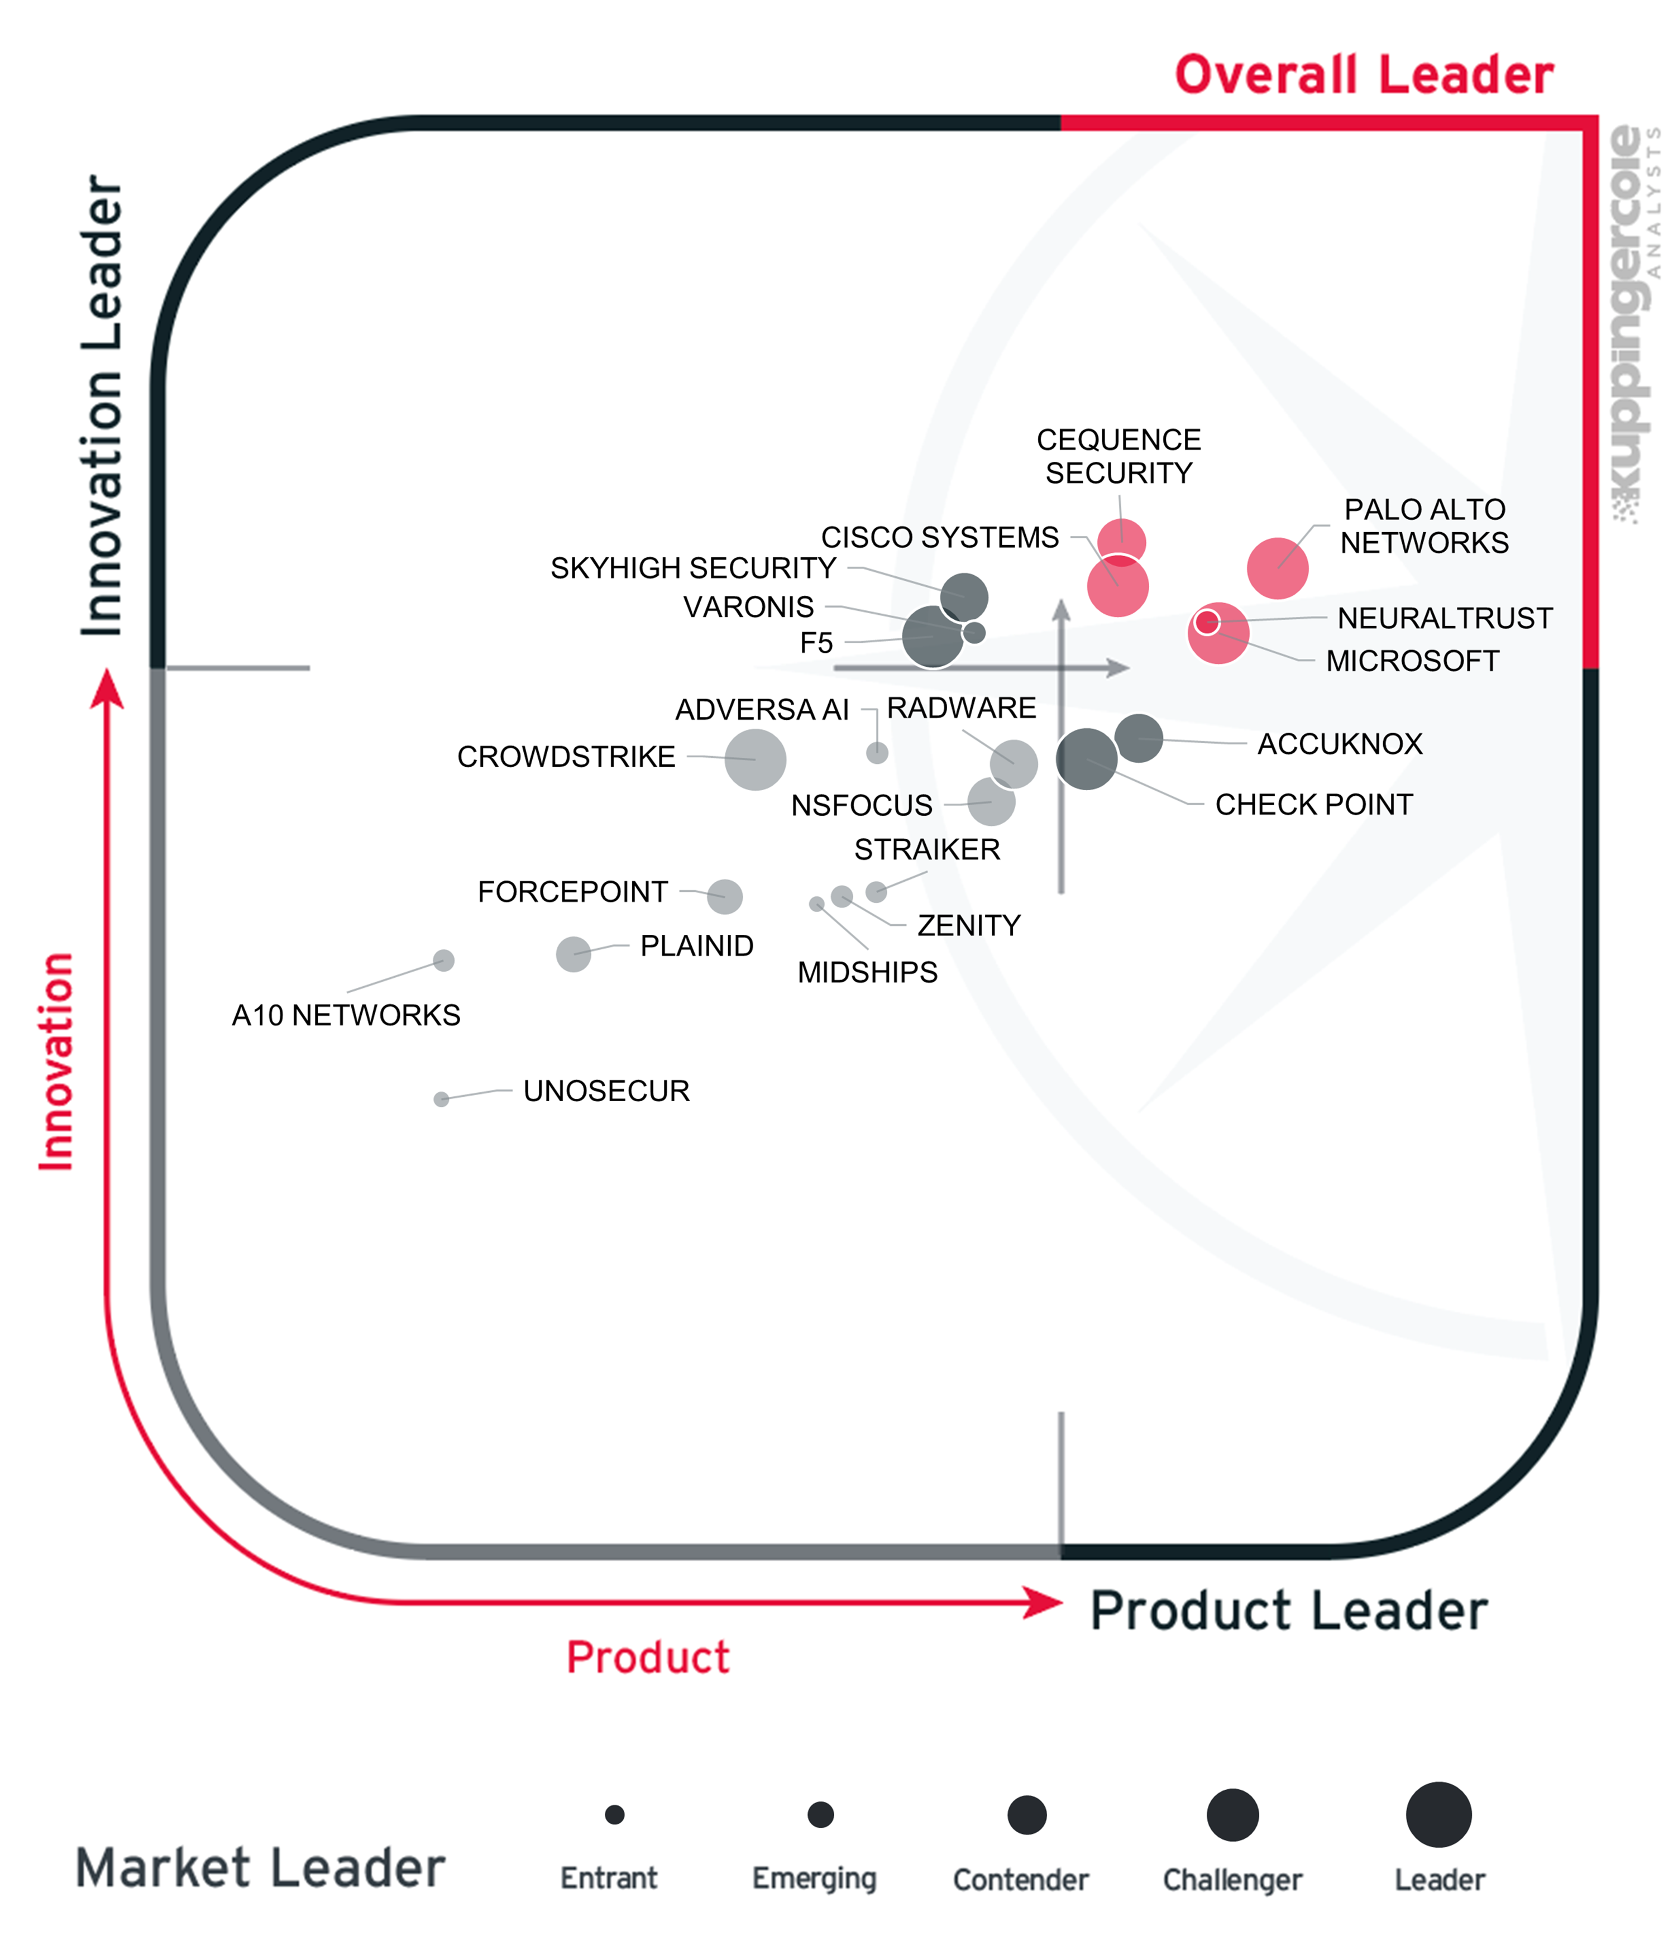
The Overall Leaders are Cequence Security, Cisco Systems, Microsoft, NeuralTrust, and Palo Alto Networks.
- Cequence Security builds agent security on Agent Personas, with discovery of agents, MCP servers, and APIs.
- Cisco Systems combines AI asset discovery, adaptive red teaming, and Policy Studio in AI Defense.
- Microsoft provides agent identity through Entra Agent ID and Purview data security for AI interactions, with the deepest protection inside the Microsoft estate.
- NeuralTrust applies one set of policies across every AI surface, including LLM, agent, and MCP traffic.
- Palo Alto Networks covers the whole AI lifecycle and reuses its mature detection, DLP, and threat intelligence.

Product Leadership
Product leadership is the first specific category examined below. This view is based on the presence and completeness of required features as defined in the required capabilities section above. The chart is horizontal and divided into two areas, the vendors to the right of the chart and colored red are Product Leaders and those to the left and colored black are Product Leadership Challengers.
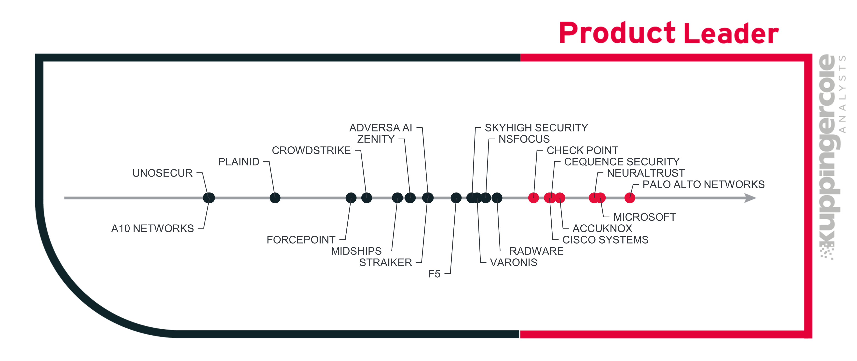
The Product Leaders in order of placement are Palo Alto Networks, Microsoft, NeuralTrust, AccuKnox, Cequence Security, Cisco Systems, and Check Point. Product leaders have the most complete mix of functionality, security, interoperability, deployment options, and usability, as defined in the required capabilities section above. Palo Alto Networks and Microsoft lead on breadth, extending AI protection across their wider security and data platforms. NeuralTrust and AccuKnox show that specialists can match that breadth: NeuralTrust applies one set of policies across every AI surface, and AccuKnox adds kernel-level runtime enforcement and air-gapped deployment. Cequence Security and Check Point stand out for control of agent tool calls, and Cisco Systems for AI asset discovery and adaptive red teaming.
The remaining vendors are challengers in Product Leadership.

Innovation Leadership
Next, we examine innovation in the marketplace. Innovation is, from our perspective, a key capability in all IT market segments. Customers require innovation to meet evolving and even emerging business requirements. Innovation is not about delivering a constant flow of new releases. Rather, innovative companies take a customer-oriented upgrade approach, delivering customer-requested and other cutting-edge features, while maintaining compatibility with previous versions.
This view is based on the evaluation of innovative features recently added together with the vendor’s history in innovation. The chart is horizontal and divided into two areas, the vendors to the right of the chart and colored red are Innovation Leaders and those to the left and colored black are Innovation Leadership Challengers.
Innovation Leaders are those vendors that deliver cutting-edge products, not only in response to customers’ requests but also because they are driving technical changes in the market by anticipating what will be needed in the months and years ahead.
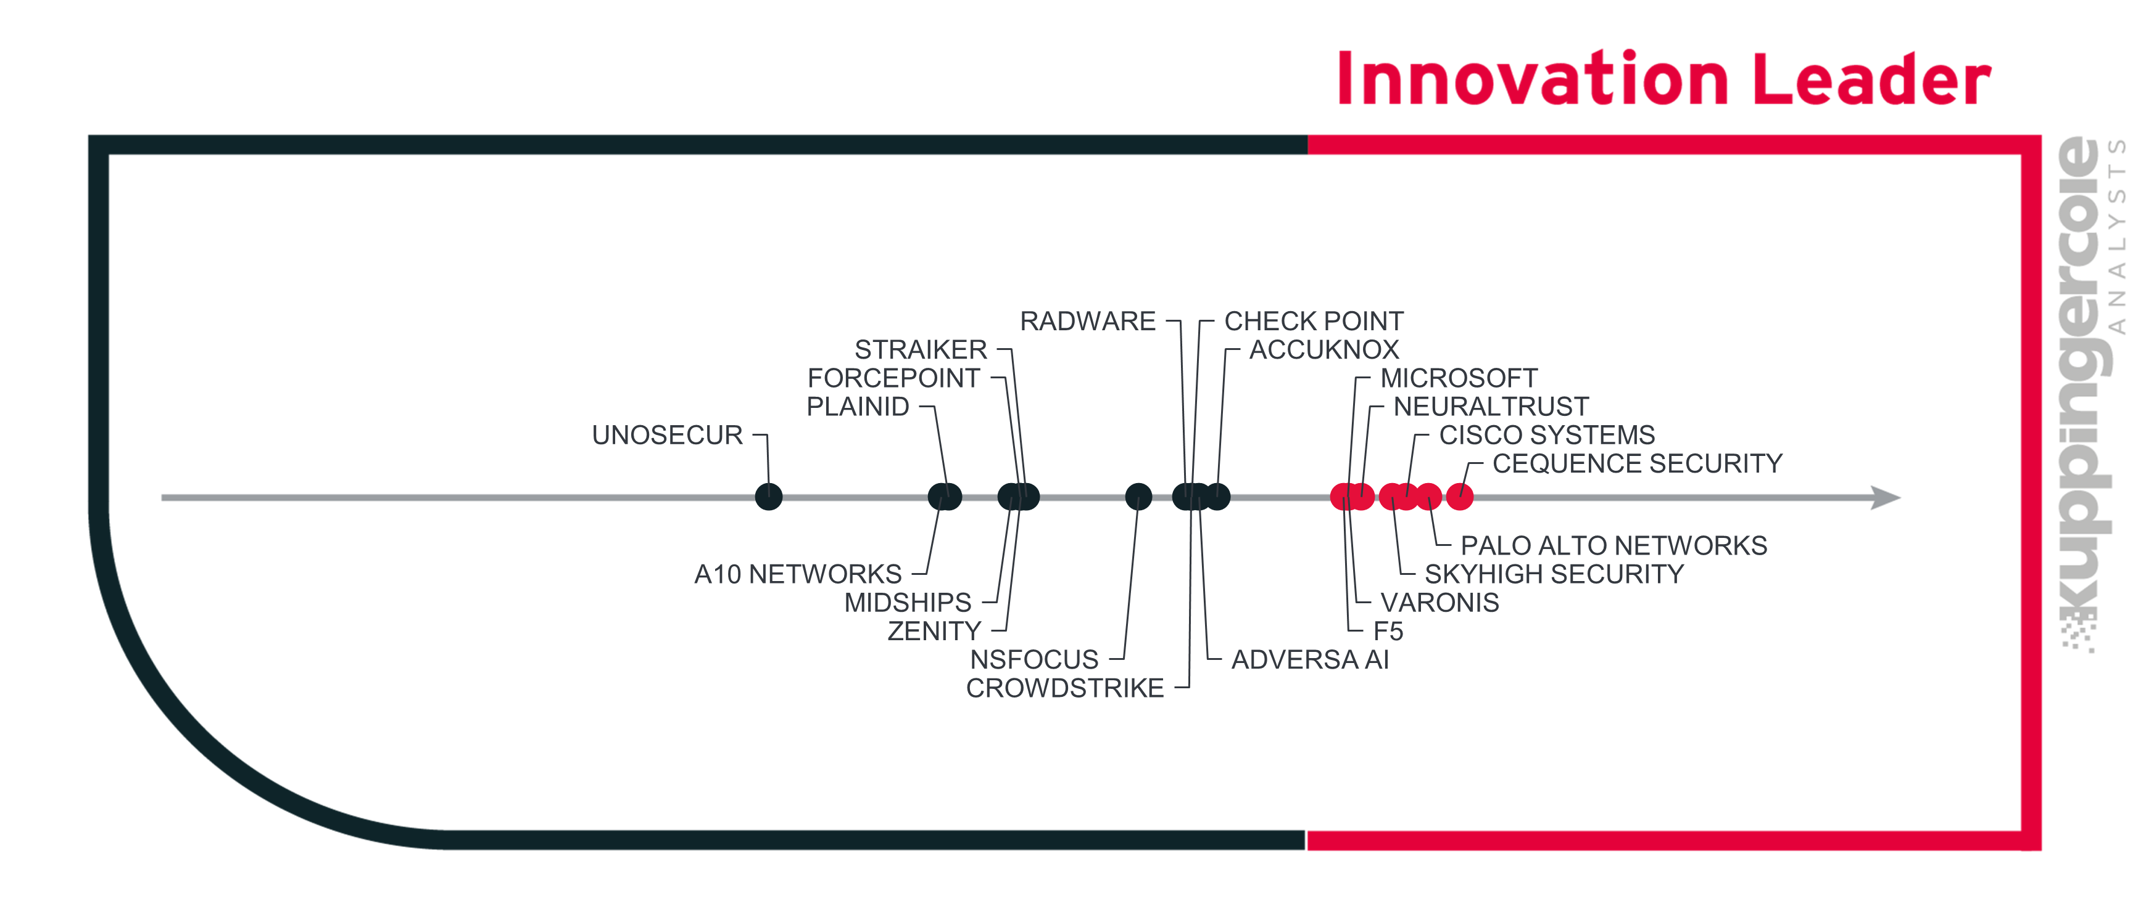
There is a correlation between the Overall, Product, and Innovation Leaders, which demonstrates that leadership requires feature-rich products that are looking over the horizon to bring advancements to help their customers. Innovative features in Generative AI Defense include behavioral analysis of AI agents to detect anomalous or unauthorized action sequences, human approval for high-risk agent actions, continuous red teaming that adapts to new attack techniques, provenance tracking for AI-generated content, natural language policy authoring and investigation, and token budgets and rate limits per user, application, or agent.
The Innovation Leaders in this edition of the Leadership Compass on Generative AI Defense are Cequence Security, Palo Alto Networks, Cisco Systems, Skyhigh Security, NeuralTrust, Microsoft, Varonis, and F5.
Other vendors placed as challengers in Innovation Leadership.

Market Leadership
Finally, we analyze Market Leadership. This is an amalgamation of the number of customers and their geographic distribution, the size of deployments and services, the size and geographic distribution of the partner ecosystem, and the financial health of the participating companies. Market Leadership, from our point of view, requires global reach.
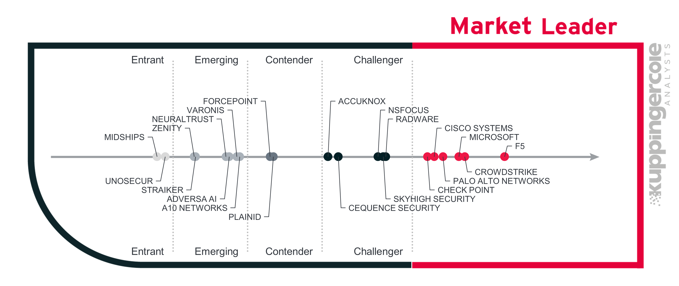
F5 leads the Generative AI Defense market by a big margin. CrowdStrike and Microsoft appear next, with significant market share. All three of the top Market Leaders are well known in cybersecurity, with vast deployments encompassing most of the other segments in the space. Palo Alto Networks, Cisco Systems, and Check Point are also Market Leaders, with large sets of customers spanning the globe.
- Radware, Skyhigh Security, NSFOCUS, Cequence Security and AccuKnox are the Challengers.
- Forcepoint and PlainID are Contenders.
- A10 Networks, Adversa AI, Zenity, NeuralTrust, Straiker, and Varonis are Emerging vendors in this market.
- Midships and Unosecur appear as Entrants.
The Generative AI Defense market is steadily growing, and all these vendors have ample opportunity to gain additional customers and market share.

Product and Vendor Evaluation
This section provides a structured evaluation of each product and vendor included in this KuppingerCole Analysts Leadership Compass. Each profile contains a description of the company and its offering, an analysis of relevant capabilities for this market segment, and an assessment of strengths and challenges. Where applicable, vendors are positioned as Leaders in the Product, Innovation, or Market categories.
In addition to these standard Leadership Compass categories, we provide detailed capability ratings for every vendor. These ratings are visualized in a spider chart that reflects performance across the functional and technical criteria defined for this market segment. The spider chart complements the written analysis and enables direct comparison across solutions.
For this Leadership Compass, the capability categories evaluated are described below.
Security: This covers the degree of security provided by the product or service. For products, it looks at internal security practices and controls that enable secure customer use, including authentication, access controls, and encryption. It also considers known vulnerabilities, how the vendor responds to them, and the presence of relevant security features. For services, it evaluates the security and consistency of operational processes and the presence of pertinent certifications.
Deployment: This covers how easy or difficult it is to deploy, operate, and discontinue the product or service. For products, it considers implementation effort, operational complexity, and the degree to which required components are integrated. It also looks at what is needed to manage the solution over time, including upgrades and decommissioning. For services, it evaluates the number and complexity of deployed components and the effort required to set up and run the service.
Interoperability: This covers the ability of the product or service to integrate with other vendors’ products and widely used standards and technologies. It considers support for common protocols and formats, as well as the availability of secure and well-documented APIs for programmatic access. For service providers, it also evaluates the ability to deliver solutions that integrate into customer applications, infrastructure, and operational workflows.
Usability: This covers how easy the product or service is to use and administer. For products, it looks at whether user interfaces are logical and intuitive and whether the experience is consistent across the vendor’s components. It also considers administrative efficiency and the clarity of configuration and reporting workflows. For services delivered by system integrators or managed service providers, it evaluates customer experience through the quality-of-service delivery, communications, and day-to-day operational interaction.
Prompt Injection Prevention: This category measures the ability to detect and block direct and indirect prompt injection, including instructions hidden in retrieved documents, web content, and tool outputs. It also covers jailbreak detection, multi-turn and chained attacks, multilingual and obfuscated attacks, and attempts to extract system prompts. The breadth of pre-built defenses, the ability to write custom guardrail rules, and the latency of inline enforcement are also evaluated.
Data Leakage Prevention: This category examines how well the solution prevents sensitive, regulated, or proprietary data from leaving the organization through AI interactions. It covers detection and redaction of Personally Identifiable Information (PII), secrets, and confidential data in prompts, responses, and retrieved content, as well as protection against training-data extraction, model inversion, and membership inference. Integration with enterprise DLP platforms, data catalogs, and classification labels, and pre-configured templates for GDPR, Health Insurance Portability and Accountability Act (HIPAA), and Payment Card Industry Data Security Standard (PCI DSS) are also considered.
Model Security Controls: This category covers the protection of models across their lifecycle. It evaluates tamper detection, cryptographic integrity verification, and protection against model theft and weight extraction. It also considers defense against training-data and model poisoning, backdoor detection, and scanning of third-party and open-source models, serialized model files, and datasets for supply-chain risk. Automated red teaming and adversarial testing of models and AI applications are included in this category.
Content Safety Filtering: This category measures the ability to inspect and control AI-generated output before it reaches users. It covers filtering of harmful, toxic, biased, off-topic, and policy-violating content, detection of hallucinated or ungrounded output in RAG applications, and detection of sensitive data in responses. Coverage across text, code, image, audio, and video, configurable severity thresholds, multi-turn analysis, and authorized override workflows with logging are also evaluated.
Logging & Auditing: This category examines how AI interactions are recorded for security operations, compliance, and forensics. It considers whether logs are immutable and tamper-evident, whether they capture full context such as prompts, responses, model version, policy decisions, and user identity, and whether privacy controls apply to logged data. Integration with SIEM, SOAR, and ITSM platforms through named connectors and standard formats, and the availability of compliance reports, are also assessed.
Governance Frameworks: This category measures support for establishing and enforcing responsible-AI policies and demonstrating regulatory compliance. It covers mapping of controls to the OWASP Top 10 for LLM Applications, MITRE ATLAS, and the NIST AI Risk Management Framework (AI RMF), pre-built frameworks and reporting for the EU AI Act and other regional regulations, and industry-specific policy templates. Risk classification of AI applications, governance dashboards, impact assessments, and policy versioning are also considered.
AI Security Posture Management: This category evaluates the ability to discover, inventory, and assess AI assets across the enterprise. It covers automatic discovery of models, applications, endpoints, and agents, detection of shadow AI, and a continuously updated inventory. It also considers data flow mapping, detection of misconfigurations and excessive permissions, risk scoring of AI assets, and continuous monitoring for posture drift.
Agentic AI Security: This category examines controls for autonomous AI agents. It covers governance of the tools, APIs, and data an agent can access, least-privilege scoping, and security for MCP servers and agent-to-agent communication. It also evaluates agent identity and authentication, detection of prompt injection through tool outputs, behavioral analysis of agent action sequences, kill switches, and human-in-the-loop approval for high-risk actions.

AccuKnox – AI Security
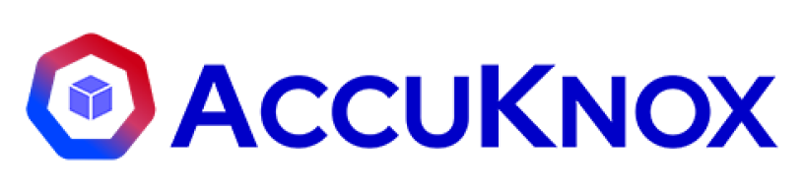
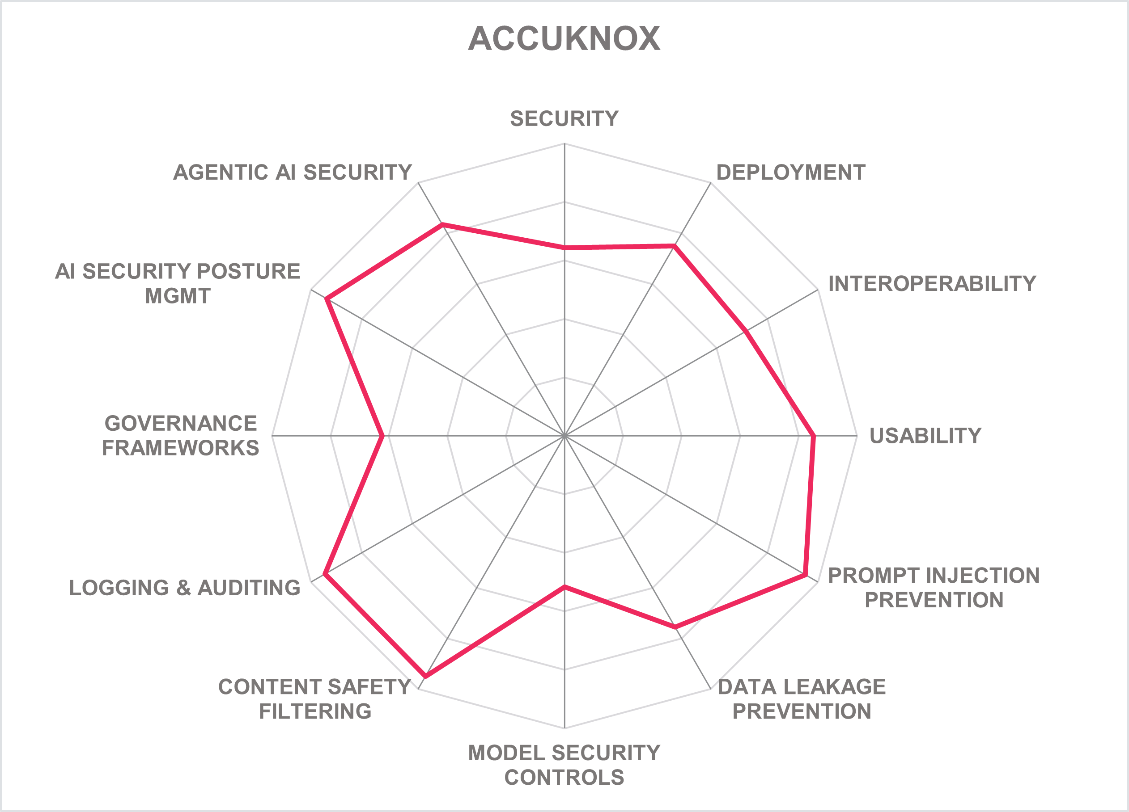
Leadership |  | 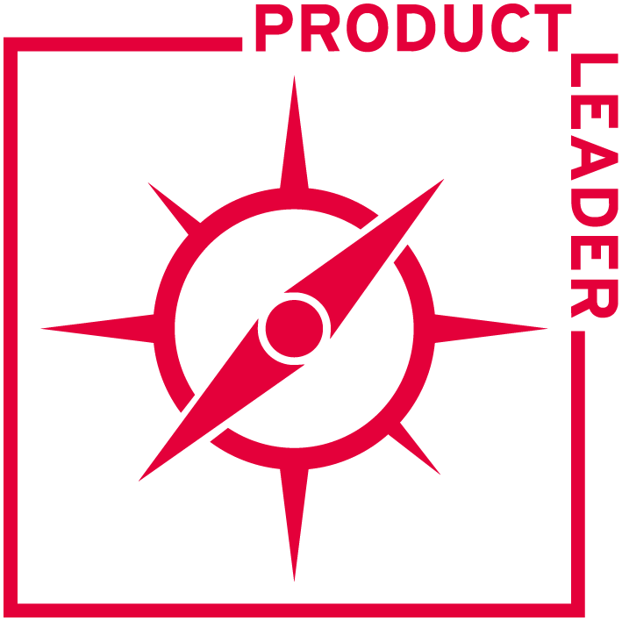 | 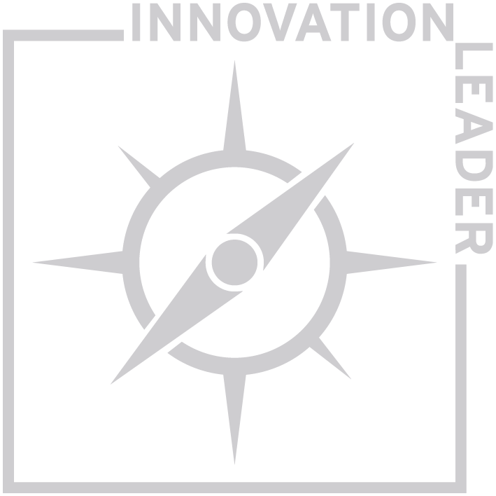 | 

AccuKnox, founded in August 2020 in partnership with SRI International and based in Cupertino, California, is a private company backed by venture capital. AccuKnox holds US patents on kernel-level security enforcement. The most recent, US Patent 12,730,882 B2, was granted on September 8, 2026. It tracks unknown processes in the kernel and blocks them only when they try to reach sensitive assets. The company grew out of zero-trust runtime security for Kubernetes and containers. AccuKnox AI Security is built on two open-source projects: KubeArmor, a Cloud Native Computing Foundation (CNCF) project that enforces policy through extended Berkeley Packet Filter (eBPF) and Linux Security Modules, and ModelArmor, which applies the same enforcement to AI and LLM workloads. AccuKnox AI Security is part of the wider AccuKnox Cloud Native Application Protection Platform (CNAPP) and has eight modules: AI Security Posture Management (AI-SPM), agentic AI security, detection and response, guardrails, AI red teaming, AI identity security, model and data security, and governance, risk, and compliance. Customers are concentrated in North America (NA), followed by Asia-Pacific (APAC), led by India, and Europe, the Middle East, and Africa (EMEA), mainly the Middle East and Eastern Europe. Licensing options include fixed cost, per node, per appliance, and per server. It runs as a cloud service, as on-premises software including air-gapped installations, or as a managed service.
Administrators sign in with accounts in AccuKnox's own directory or other enterprise directories, or through SAML and OIDC federation. Administrator Multifactor Authentication (MFA) options include tokens, authenticator apps, passkeys, and one-time passwords. AccuKnox supports delegated administration with RBAC, policy-based access control, and privileged access controls, but not Attribute-Based Access Control (ABAC). Administrative logs are tamper-evident. Transport Layer Security (TLS) 1.2 and 1.3, IPsec, and WireGuard protect data in transit. Tokenization and pseudonymization are available. In the cloud service, encryption keys are managed by the customer or by the cloud provider, with no Hardware Security Module (HSM) option. APIs authenticate with Open Authorization (OAuth) 2, SAML, OIDC, and JSON Web Token (JWT). On-premises and air-gapped deployments keep all data on customer infrastructure.
The Prompt Firewall is an inline proxy that inspects prompts in real time. It detects direct prompt injection, indirect injection in RAG-retrieved chunks, documents, and web content, jailbreaks, and attempts to extract system prompts or model information. The firewall is stateful: it tracks conversation history and cumulative risk across turns, so it catches attacks that escalate gradually over several messages. An independent review of AI firewall architectures by analyst Andrew Green found it to be the only explicitly stateful AI firewall among the six vendors compared. AccuKnox combines fast distilled classifiers with an LLM judge for escalation, together with intent scoring and session context, to limit false positives, and 24 intent types come out of the box. Multilingual attacks are covered. Policies exist at two levels, global policies for the whole organization and local policies for individual applications, built from templates or from custom regex and domain rules. Each policy type has its own action (block, monitor, or allow), plus redaction. Flagged prompts appear in a dashboard with per-policy scores and a full query trace for review, and the AskADA copilot suggests remediation steps. A simulation mode tests policies before they go live. Guardrail-as-code is on the roadmap.
Response policies inspect LLM outputs inline and apply checks and redaction before the output reaches the user. Pre-built filters cover toxicity, violence, self-harm, hate, and other harmful categories, and customers can add their own. A dedicated response policy scans generated code for known vulnerabilities and insecure functions. AccuKnox detects hallucinations by flagging contradictions and unsupported claims. Each policy returns a risk score with configurable thresholds, and the violation view explains which policy triggered and why. Content filters cover Chinese, Spanish, French, German, Portuguese, Arabic, and Japanese, and they analyze multi-turn conversations as well as single responses. Rules are scoped by application or department rather than by individual user role. Output filtering currently covers text and code only. Image, audio, and video filtering are on the roadmap, as is watermarking of AI-generated content.
The Anonymize policy uses named-entity recognition and pattern matching to detect and mask PII and Protected Health Information (PHI), such as names, social security numbers, card numbers, and medical records, in prompts, and a matching policy restores values in the response where appropriate. A Secrets policy catches API keys and credentials, and custom regex, blocklists, and banned topics let organizations define their own classes of sensitive data. The firewall scans uploaded files and structured formats such as Comma-Separated Values (CSV) and JavaScript Object Notation (JSON), detects obfuscation and encoding used to bypass controls, and monitors for repeated queries that attempt to reconstruct training data. Compliance mappings cover GDPR, HIPAA, PCI DSS, International Organization for Standardization (ISO) 27001, and NIST Cybersecurity Framework (CSF). AccuKnox enforces its own inline DLP, which runs in parallel with existing DLP platforms such as Microsoft Purview or Netskope rather than integrating with them directly. Pre-built connectors for data catalogs such as BigID, Varonis, and Microsoft Purview are on the roadmap; until then, findings can be exported. Data retention for AI interactions is configurable. Watermarking of sensitive data is planned.
Model Scanning statically inspects five model formats (Pickle, HDF5, TensorFlow SavedModel, framework checkpoints, and ONNX) for deserialization backdoors, embedded code, and unsafe operators, including models pulled from Hugging Face. Scans cover models on AWS Bedrock, Azure AI, Google Vertex AI, Ollama, vLLM, and NVIDIA NIM, run on a schedule, and re-run whenever a model artifact or its configuration changes. AccuKnox generates an AI bill of materials (AI-BOM) covering models, frameworks, inference servers, vector databases, and training datasets, as part of an xBOM view that combines it with the Software Bill of Materials (SBOM). Model weights are hash verified and pinned to specific revisions. Training datasets are scanned before deployment, and adversarial testing such as Fast Gradient Sign Method (FGSM) is available. AI Red Teaming ships more than 150 adversarial probes mapped to OWASP, MITRE ATLAS, and AI Vulnerability Database (AVID), with domain-specific suites for finance and healthcare. Intelligent Red Teaming generates prompts tailored to a model's purpose, and tests run again after every fine-tune or configuration change. Findings include severity, the exact prompt and output, and remediation guidance. ModelArmor isolates models from one another at runtime. Model watermarking is on the roadmap.
AI-SPM discovers and inventories models, applications, datasets, compute, and agents across cloud environments, SaaS, browsers, and endpoints. Shadow AI coverage is a differentiator: AccuKnox scans Virtual Machines (VMs) and containers wherever they run, including employee laptops, and can be rolled out to up to 10,000 endpoints through Ansible or Microsoft Intune. It detects shadow AI by analyzing outbound traffic and API calls. A pipeline view maps data flows between applications, models, services, and external providers. AccuKnox detects misconfigurations, exposed AI API keys and secrets, and excessive permissions granted to AI applications and agents, and it scores assets by exposure, data sensitivity, and configuration. Posture is monitored continuously for drift, and model versions and configuration changes are tracked through the xBOM. Findings map to the EU AI Act, NIST AI RMF, and OWASP, and remediation is prioritized by risk. Policy as code applies to posture controls, and third-party AI services are assessed as well. Onboarding takes one to two weeks for cloud environments, with endpoint rollout as a separate track.
Runtime control is AccuKnox's stated core competency. ModelArmor wraps agents in an eBPF-based sandbox with default-deny policies, so an agent can reach only the tools, data, network destinations, and processes it has been granted, without code changes. The Prompt Firewall inspects content returning through tool calls and retrieved documents for injected instructions, and AccuKnox detects goal hijacking, anomalous behavior against a learned baseline, and data exfiltration through tool use. AccuKnox discovers MCP servers, scans their posture, and flags issues. Agent actions and tool calls are logged in an auditable trace, and agent execution can be blocked in real time. AccuKnox integrates directly with managed agent platforms such as Microsoft Copilot Studio and Amazon Bedrock AgentCore, and it automatically builds a least-privilege runtime posture around frameworks such as OpenClaw, which grants full host access by default. Agent identity verification, integrity checks for agent-to-agent communication, and human-in-the-loop approval for high-risk agent actions are on the roadmap. AccuKnox is waiting for the Linux Foundation's Agentic AI Foundation to settle Agent2Agent (A2A) standards before implementing them.
AccuKnox enforces controls at three points. A browser extension governs employee use of public AI services such as ChatGPT, Gemini, and Perplexity. Integration with AI and API gateways, including Kong, Azure API Management, Amazon API Gateway, Apigee, and LiteLLM, inspects prompts and responses in transit. Direct integrations cover managed agent platforms. Input and output policies are enforced separately. The Prompt Firewall blocks anomalous or abusive request patterns, and secret scanning detects exposed or misused credentials. However, most user-level access controls are still planned. Role-based access to specific models or agents, least-privilege access for AI users, time-bound permissions, and API-level authentication and throttling for embedded AI are all on the roadmap. Until they arrive, organizations must rely on their existing IAM and gateway controls for these functions.
Governance builds on the CNAPP's GRC module, which offers more than 30 compliance programs across industries. For AI, findings map to frameworks including the OWASP LLM Top 10, MITRE ATLAS, NIST AI RMF, the EU AI Act, ISO 27001, SOC 2, PCI DSS, HIPAA, and GDPR; ISO 42001 is on the roadmap. Regional coverage includes the EU, US, UK, APAC, and the Middle East, with financial regulations such as the Reserve Bank of India's guidelines, the Securities and Exchange Board of India (SEBI) Cybersecurity and Cyber Resilience Framework (CSCRF), the Saudi Central Bank (SAMA) framework, and Korean financial guidelines. China and Canada are on the roadmap. Industry policy templates cover healthcare, finance, manufacturing, education, and the public sector, although many are based on general frameworks such as Center for Internet Security (CIS), NIST, and ISO 27001 rather than on AI-specific rules. A central dashboard shows AI usage, and compliance reports can be exported for auditors. Data sovereignty is supported through SaaS, on-premises, air-gapped, and regional deployments. Automatic classification of AI applications by EU AI Act risk tier and version control for governance policies are on the roadmap.
AuditTrail and EventTrail record prompts, responses, users, policy decisions, and violation scores, with user attribution for every AI interaction, and every guardrail decision is logged with the policy that triggered it. Logs are protected against tampering, retention is configurable, sensitive data can be redacted from logs, and historical interactions can be searched and filtered. Events forward to Splunk, IBM QRadar, syslog, and Representational State Transfer (REST) or webhook endpoints. Connectors for Microsoft Sentinel, Elastic, and Google Chronicle are on the roadmap. AccuKnox also offers its own cloud-native SIEM, which ingests AI Detection and Response (AI-DR), Prompt Firewall, and posture events, correlates them with wider cloud security telemetry, and raises real-time alerts. Compliance reports cover data privacy regimes such as India's Digital Personal Data Protection Act (DPDPA) and California Consumer Privacy Act (CCPA), as well as ISO 27001, PCI DSS, HIPAA, and Federal Information Security Modernization Act (FISMA); Sarbanes-Oxley Act (SOX) reporting is in development. Dashboards show AI usage patterns across the organization.
It monitors AI and agent workloads in real time for probing and malicious activity, blocks unauthorized installations and file system changes, and isolates compromised workloads. AI Detection and Response (AI-DR) reconstructs attack chains across prompts, tool calls, and control-plane events and can trigger automated remediation. It runs out of band, outside the inference path. Enforcement is graduated rather than a simple block or allow, so AI systems can keep running with reduced capability during an incident. Events flow to SIEM, SOAR, and ticketing platforms such as Jira and ServiceNow through webhooks and pre-built integrations. AccuKnox provides documented response guidance for common incidents such as prompt injection, jailbreaks, and data leakage, threat hunting across its AI modules, and post-incident reporting. A findings lifecycle tracks vulnerabilities from detection to resolution, with risk-based remediation guidance. Forensic support relies mainly on logs and audit trails rather than on dedicated chain-of-custody tooling.
AccuKnox uses supervised classifiers to score prompts and responses, together with named-entity recognition, topic classification, and perplexity scoring. The guardrail model behind these verdicts, AccuKnox Guard 1.1, ranked first of 41 open guardrail models on the independent GuardRate leaderboard on Hugging Face (October 16, 2026 snapshot). It scored 0.808, with a 13.7% false-positive rate and 72.3 ms p95 latency at 4.5 billion parameters. Verdicts do not depend on an LLM. Unsupervised behavioral baselining in KubeArmor and ModelArmor learns normal workload behavior and flags deviations. ML-driven enforcement runs in monitor mode by default and acts autonomously only where the customer enables it. The toxicity detector also calls the externally hosted Google Perspective API, which customers can disable. Generative features are opt-in and disabled by default. GPT-4o powers the AskADA copilot and remediation suggestions in the cloud service, receiving sanitized finding context for tenants that opt in. Optional Static Application Security Testing (SAST) analysis runs on Claude with the customer's own API key, and on-premises deployments use locally hosted open-weight models. RAG is tenant-scoped, and customer data is not used to train models. In AgentZ, AccuKnox's own agent platform, agents plan within policy boundaries, mutating actions are denied by default, and human approval is the default setting.
Five AI security modules reached general availability at RSAC 2026. Roadmap items named in the questionnaire include agent identity, A2A support, human-in-the-loop approval, role-based AI access controls, and multi-modal output filtering. AccuKnox holds ISO 27001, SOC 2, and Common Criteria certifications. Support is 24/7 in English, French, and Japanese, with professional services worldwide. AccuKnox has completed more than 50 proofs of concept, and references include Airbus, which runs 18 AI teams under an AI center of excellence. Further references include a US Department of War research organization, which selected AccuKnox after a 12-month proof of concept of eight vendors. A global airline protects more than 40 AI agents across AWS Bedrock, Azure AI Foundry, and Copilot Studio. A leading Asian stock exchange runs an on-premises proof of concept. NVIDIA is a partner for securing AI factories.
AccuKnox is a Leader in Product Leadership and a Challenger in the Innovation, Market, and Overall Leadership ratings. Its strengths are kernel-level runtime enforcement and deployment options that include air-gapped installations. Its challenges are access controls and agent identity features still on the roadmap, and a small company relative to its platform scope. AccuKnox is best suited to organizations that run AI workloads on Kubernetes or in regulated or sovereign environments, want AI security combined with cloud application protection, and need an AI asset inventory that extends to employee devices.
Strengths
- Kernel-level runtime enforcement for models and agents through ModelArmor and KubeArmor, with default-deny sandboxing
- Stateful Prompt Firewall that tracks risk across conversation turns
- Guardrail model ranked first of 41 on the independent GuardRate leaderboard
- Content safety filters across harm categories, with code vulnerability scanning and hallucination detection
- Shadow AI discovery that extends to employee endpoints and browsers
- AI-BOM and xBOM supply-chain visibility
- Red teaming with more than 150 built-in probes, run again after every model change
- Broad compliance mapping, including the EU AI Act, NIST AI RMF, and regional financial regulations
- On-premises and air-gapped deployment with no external model calls
- Single platform combining AI security with CNAPP, built on CNCF open-source projects
Challenges
- Small company relative to the breadth of its platform, with limited resources to develop and support every module
- Model security is its weakest capability area, a limitation for organizations that host or fine-tune their own models
- Agent controls are still maturing, with no agent identity verification, agent-to-agent integrity checks, or human approval for actions of third-party agents, although human approval is the default in AccuKnox's own AgentZ platform
- No role-based or time-bound access control for AI users until those roadmap items are delivered
- No integration with enterprise DLP platforms

Related Research
Buyer's Compass: GenAI Defense
Leadership Compass: Generative AI Defense (2025)
Advisory Note: Navigating the Agentic AI Security Landscape
Advisory Note: When AI Agents Break the Security Model: The Identity Layer As the Fault Line
Whitepaper: Beyond Benchmarks: Measuring the Security Efficacy of Enterprise AI Guardrails
Leadership Brief: Model Context Protocol: The API Security Problem Nobody Is Ready For
Leadership Brief: No API Security, No AI Security
Leadership Compass: SaaS Security and AI Governance
Leadership Compass: Cloud Native Application Protection Platforms (CNAPP)
Leadership Compass: API Security and Management
Leadership Compass: Non-Human Identity Management
Leadership Compass: Software Supply Chain Security

Copyright
© 2026 KuppingerCole Analysts AG. All rights reserved. Reproducing or distributing this publication in any form is prohibited without prior written permission. The conclusions, recommendations, and predictions in this document reflect KuppingerCole Analysts' initial views. As we gather more information and conduct deeper analysis, the positions presented here may undergo refinement or significant changes. KuppingerCole Analysts disclaims all warranties regarding the completeness, accuracy, and adequacy of this information. Although KuppingerCole Analysts' research documents may discuss legal issues related to information security and technology, we do not provide legal services or advice, and our publications should not be used as such. KuppingerCole Analysts assumes no liability for errors or inadequacies in the information contained in this document. Any expressed opinion may change without notice. All product and company names are trademarks™ or registered® trademarks of their respective holders. Their use does not imply any affiliation with or endorsement by them.
KuppingerCole Analysts supports IT professionals with exceptional expertise to define IT strategies and make relevant decisions. As a leading analyst firm, KuppingerCole Analysts offers firsthand, vendor-neutral information. Our services enable you to make decisions crucial to your business with confidence and security.
Founded in 2004, KuppingerCole Analysts is a global, independent analyst organization headquartered in Europe. We specialize in providing vendor-neutral advice, expertise, thought leadership, and practical relevance in Cybersecurity, Digital Identity & IAM (Identity and Access Management), Cloud Risk and Security, and Artificial Intelligence, as well as technologies enabling Digital Transformation. We assist companies, corporate users, integrators, and software manufacturers to address both tactical and strategic challenges by making better decisions for their business success. Balancing immediate implementation with long-term viability is central to our philosophy.
For further information, please contact clients@kuppingercole.com.

